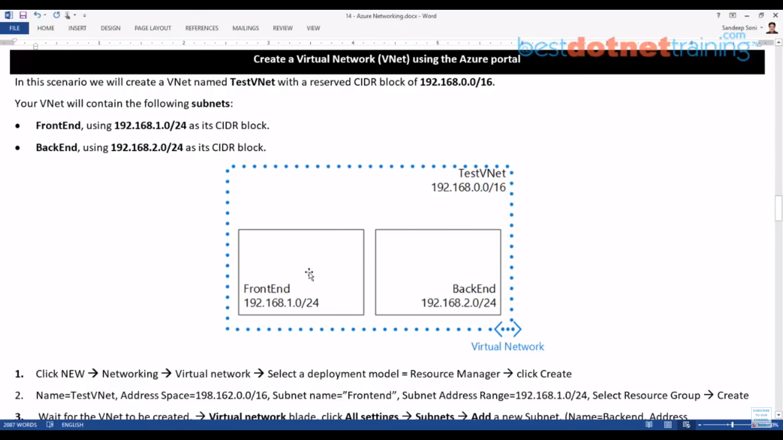

Create a VNet

In IP Addresses , add 19.168.0.0/16

Create one Subnet FrontEndSubNet, In Ip Addresses , give 192.168.1.0/24

Add one more subnet, BackEndSubNet, In IP Addresses, give 192.168.2.0/24

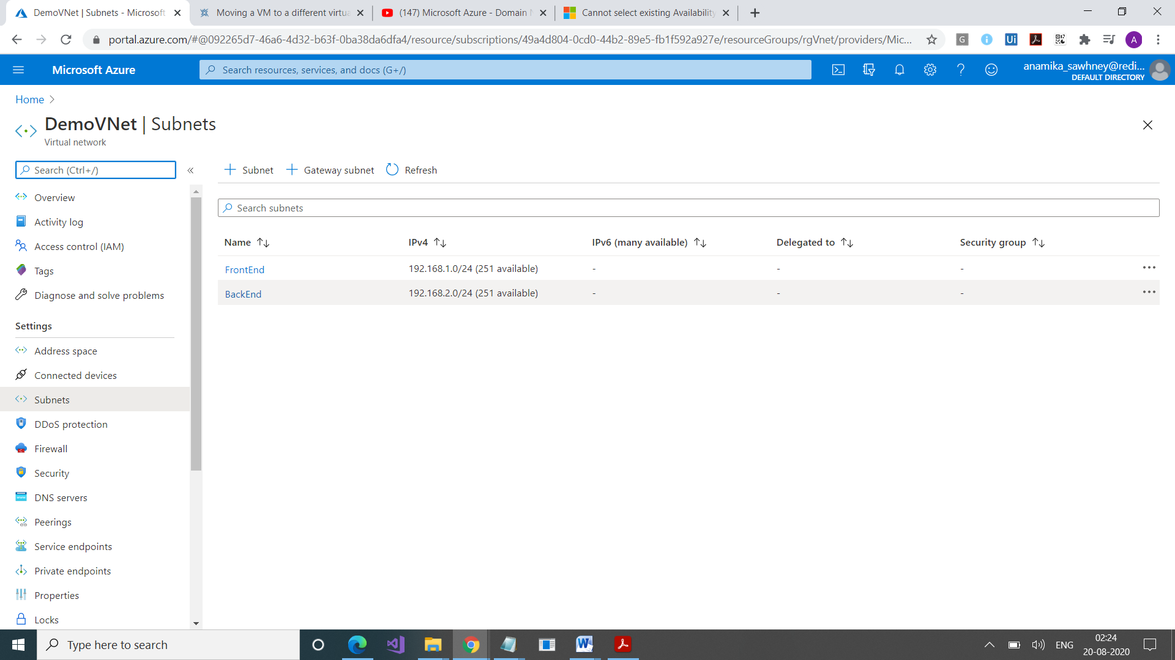

Both do not have NSG, Route Table

Why do we have only 251. Coz first 4 IP addresses and the last are reserved.

Now, we will create NSG.

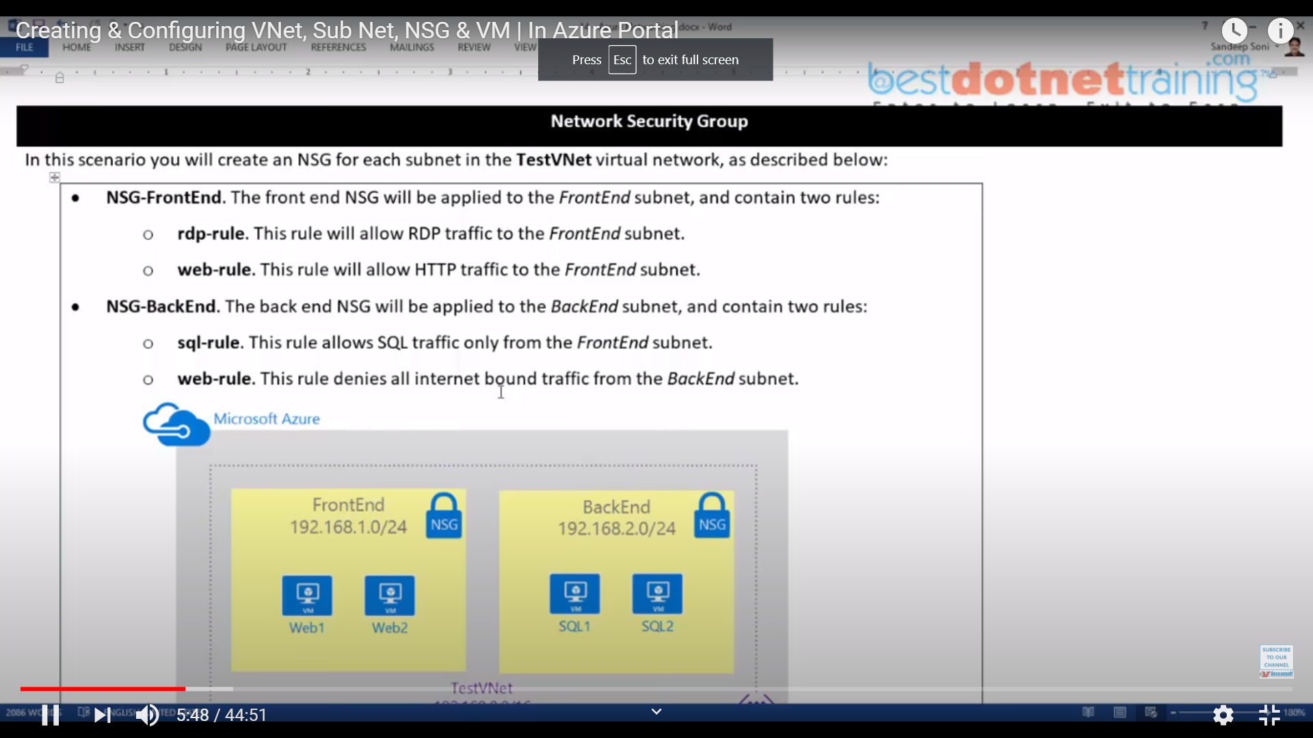

Create 2 NSG , FrontEndNSG, BackEndNSG

Now go to FrontEndNSG, here we can add Inbound and Outbound Rules

Now go to BackEndNSG, here we can add Inbound and Outbound Rules

Now, associate these NSG rules with Subnet

Now, create VM